Appendix 14: SWIFT Consent Call to Parent for Adolescent Interview





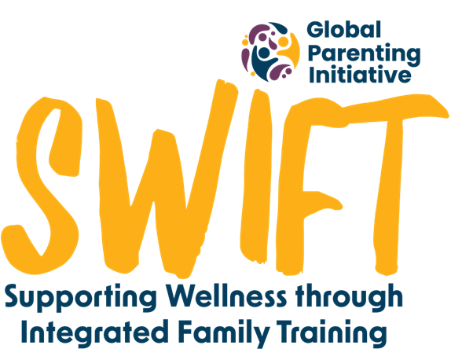


Before making this call a member of the team should have sent a copy of the consent form to the parent along with the following message from the study WhatsApp number.
Hello. This is _______ from the SWIFT research team looking at the ParentText Chatbot you have been interacting with. I have sent you a copy of the information form which you got when you said that we could interview your child a while back. They have been selected for the second interview which we explained in the form. One of our team will be calling you to go over the information, get your consent and set up a time to call your child. Please have a look at it before the call, if possible, so that you can ask any questions you have. Thanks!
Call script
Hi there. I’m ____________. I’m calling from the SWIFT research team looking at the ParentText Chatbot you have been interacting with. A while back, you gave consent for your child to be interviewed by our team. As you may know we have already done the shorter survey interview, but your child has also been selected for the one-on-one telephonic interview. You would have received a message from our team with the information sheet, saying that we will be calling you. Is this a good time for you?
If they answer no, get an alternate time to call back, if yes proceed.
I’m calling to get your consent to interview ___________ and before you give it to me, I wanted to make sure you have gone through the consent form to make sure you know all the details you need to know to give that consent. Have you read it already or would you like me to go through it with you now?
If they haven’t read it. Say…  Please stop me as I’m going if anything isn’t clear or if you have any questions. I will also make sure that all your questions are answered at the end.  Proceed to read consent form slowly  Do you have any questions?  Proceed to informed consent to take part in study below | If they have read it. Say…  I’m glad that you went through it. Do you have any questions?  I know that you have read it, but I would just like to go over the last part which is the consent part.  Proceed to informed consent to take part in study below

Informed Consent to Take Part in the Study
Please listen carefully to the following questions and reply yes if you consent. If you say no to anything, that's okay. I will go over that bit of information again and then you can confirm once you are happy.
- Do you confirm that you have read the information in the consent form and know what is expected of your child?
- Do you understand as your child’s guardian that you are giving consent for them to participate?
- Do you understand that even though you have given consent, that your child will still be able to choose freely if they want to be interviewed?
- Do you understand that they can say no to being interviewed without any consequence?
- Have you had time to think about the information?
  - Have you asked any questions you had?
  - Are you satisfied with the answers you got if you did have questions?
- Do you know who can see your child’s information, how it will be kept safe, and what happens to it after the study?
- Do you understand that you will not be notified of your child’s answers?
- Do you understand that if the researchers pick up any safety concerns while interviewing your child, they will let your child know that they will have to share the information, and then they will share it with you?
- Do you understand that you and your child won’t be named in any results, papers or reports from this study?
- Do you know who to contact if you have a problem with the study?
- Can one of the team contact you again if more information is needed from you?
- Can we keep your contact information so we can tell you about the results of the study?

- Do you give us consent to contact your child and for them to take part in the interview?

I would like to set up a time which will work for us to call your child for the interview. But I just want to make sure that when we do call, they will be able to speak privately in a space where they won’t be disturbed or overheard. Would you please be able to help us make sure that they are able to talk without anyone overhearing them, even you. This is to ensure their privacy and confidentiality. I know it’s difficult in some of our houses, but can you think of a time and space where this is possible? (explore this space with them or how to perhaps put something in place)
Thank you so much. We will call _________ at ____________ on the __________ .

